PHASE AND POTENTIAL
Merging Feynman’s Quantum Electrodynamics
with Mead’s Collective Electrodynamics

Toward a Unified Quantum Foundation of Electromagnetism

Expanded First Draft with Mathematical Appendix and Figures
August 2026

For Richard Feynman,
who taught us that the glory of science
is finding a way of thinking such that the law is evident,

and for Carver Mead,
who took that charge seriously
and rebuilt electromagnetism from the quantum phase of matter.

Preface to the Expanded Draft
This expanded first draft incorporates three major additions requested by the reader: (1) substantially developed chapter content throughout the manuscript, (2) a complete Mathematical Appendix that derives the key relations of Collective Electrodynamics and their contact with QED in a deliberately clear, step-by-step manner, and (3) original figures illustrating the central ideas.
The core argument remains unchanged. Feynman’s Quantum Electrodynamics and Mead’s Collective Electrodynamics are complementary descriptions of the same electromagnetic reality. The microscopic theory supplies precision and the high-energy structure; the collective theory supplies the conceptual starting point that makes the quantum origin of electromagnetism visible and removes the necessity of treating the electromagnetic field as an independent ontological entity.
The Mathematical Appendix is written so that a reader comfortable with undergraduate electromagnetism and the basic ideas of quantum mechanics can follow every step. No advanced quantum field theory is assumed. The figures are placed near the first discussion of the concepts they illustrate.
A finished 190-page academic monograph would still require additional worked examples, a fuller historical apparatus drawn from the Caltech archives, and an exhaustive bibliography. What follows is already a self-contained and substantially expanded argument.
August 2026

Contents
Preface
Part I. Roots and Divergences
1. The Problem of Foundations
2. Wheeler, Feynman, and the Absorber Theory
3. Mead at Caltech and the Motivation for Collective Electrodynamics
Part II. Feynman’s Quantum Electrodynamics
4. Path Integrals, Photons, and the Structure of QED
5. Minimal Coupling and the Primacy of the Potentials
6. Radiation Reaction, Self-Interaction, and the Limits of the Field Picture
Part III. Collective Electrodynamics
7. The Superconducting Loop as the Elementary System
8. Phase, Flux Quantization, and the Vector Potential
9. Energy, Momentum, and the Collective Square Law
10. Radiation, Energy Transfer, and the Absence of Independent Fields
Part IV. The Synthesis
11. Coherent States and the Collective Limit of QED
12. Path Integrals over Collective Degrees of Freedom
13. Gauge Freedom, Phase Continuity, and the Status of the Photon
14. Recovering Classical Electromagnetism and Ordinary QED Processes
Part V. Implications and Frontiers
15. A Pedagogical Sequence That Begins with Quantum Coherence
16. Open Problems, Experimental Touchstones, and Possible Extensions
17. Toward a Single Language for Electromagnetism
Mathematical Appendix
A. Einstein–de Broglie Relations and Phase Accumulation
B. Flux Quantization from Phase Continuity
C. The Vector Potential and Minimal Coupling
D. Collective Momentum and the N² Scaling
E. Electromagnetic Energy in the Collective Picture
F. Contact with the Path Integral of QED
Figures
References

Part I. Roots and Divergences
The history of electromagnetism is usually presented as a sequence of successful equations that successively refined an essentially stable ontology. Maxwell’s equations, the Lorentz force, the quantization of the field, renormalization. Each step is described as an improvement that preserves the core picture of the previous step. This narrative is incomplete. At several critical moments the conceptual starting point could have been chosen differently. The choices that were made were often dictated by the experimental situation and the mathematical tools then available, not by logical necessity.
This Part examines three such junctures: the decision to treat the electromagnetic field as an independent entity carrying its own energy and momentum; the decision to begin the teaching of electromagnetism with the field strengths E and B rather than the potentials; and the decision to take classical particle mechanics as the correspondence limit for quantum systems of many charges. Feynman and Mead each questioned one or more of these decisions. Their questions, placed side by side, define the conceptual space in which a synthesis becomes possible.

1. The Problem of Foundations

1.1 The Classical Inheritance
James Clerk Maxwell constructed his theory of the electromagnetic field in the middle of the nineteenth century. The only ontology available to him was that of classical continuum mechanics. The field was therefore imagined as a state of stress or strain in a mechanical medium—the luminiferous ether. Electric and magnetic forces were the result of that stress acting on charged matter. When the ether was later abandoned, the field equations remained, now interpreted as describing an independent physical entity that occupies space and carries energy and momentum even in the complete absence of matter.
This inheritance is still visible in every standard textbook. Maxwell’s equations are written first for the fields E and B. The potentials A and φ are introduced later as convenient mathematical auxiliaries that simplify certain calculations. The energy of the electromagnetic field is written as an integral of (ε₀/2)E² + (1/2μ₀)B² over all space. Radiation is described as energy leaving a charge and traveling through empty space until it is absorbed somewhere else. The conceptual order is classical fields first, quantum theory later.
The difficulty is that the quantum theory, when it finally arrives, does not sit comfortably on this foundation. The Aharonov–Bohm effect demonstrates that the potentials can produce observable interference even in regions where the field strengths E and B vanish identically. The path-integral formulation of quantum mechanics makes the classical action, and therefore the potentials, the primary objects that determine the phase of each history. In the Lagrangian of Quantum Electrodynamics the interaction term is the minimal coupling of the charged field to the four-potential Aμ. The classical force law F = q(E + v × B) is recovered only as an approximation valid under restricted conditions. Yet the pedagogical and conceptual order of most courses remains the classical one.

1.2 Einstein’s Remark and the Single Reality
Einstein expressed the underlying discomfort with unusual clarity. He wrote that it is a delusion to think of the electrons and the fields as two physically different, independent entities. Since neither can exist without the other, there is only one reality to be described, which happens to have two different aspects; and the theory ought to recognize this from the start instead of doing things twice. The remark appears in Mead’s book as a guiding principle. It also resonates strongly with the Wheeler–Feynman absorber program, in which the field is eliminated in favor of direct interaction between charges mediated by the potentials.
If Einstein is right, then a foundation that begins with independent fields is already a step away from the eventual quantum description. The question that organizes this entire manuscript is whether a different starting point—one that begins with the quantum phase of charged matter and the potentials that appear in that phase—can recover everything that the standard theory predicts while making the quantum origin of electromagnetism visible from the first page.

1.3 The Correspondence Problem
A second foundational issue is the correspondence principle. In the usual teaching of quantum mechanics one recovers classical mechanics by letting ħ approach zero or by considering expectation values of operators in states of large quantum numbers. For electromagnetic systems of many charges this procedure is actively misleading. A superconducting loop containing on the order of 10²³ electrons does not behave like 10²³ independent classical particles. Its electromagnetic inertia scales with the square of the number of participating charges. Its response to an applied vector potential is collective. The appropriate correspondence limit is not classical particle mechanics but classical electromagnetism expressed in terms of the potentials and the collective phase.
Mead insists on this point repeatedly and correctly. Classical mechanics is itself an approximation that becomes valid only when quantum coherence is lost and phases are randomized. To take it as the foundation for a theory of coherent electromagnetic systems is to begin in the wrong place. The correct sequence is quantum coherence first, collective electrodynamics second, and classical particle mechanics only as a further approximation that applies when the phases of the individual carriers have become incoherent.

1.4 What a Successful Synthesis Must Achieve
A successful merger of QED and Collective Electrodynamics must satisfy several simultaneous constraints. It must recover the quantitative successes of QED in the microscopic, high-energy regime—the anomalous magnetic moment, the Lamb shift, the cross sections for Compton scattering and pair production. It must recover the quantitative successes of ordinary electromagnetism in the macroscopic regime—the inductance of coils, the forces between currents, the radiation resistance of antennas. It must explain why the potentials, rather than the field strengths E and B, appear as the natural variables once quantum mechanics is taken seriously. It must clarify the status of the photon: is it an independent dynamical degree of freedom, or is it a convenient bookkeeping device for the exchange of energy and phase between charged systems? And it must do all of this without introducing two incompatible ontologies—one for the laboratory-scale coherent system and another for the scattering experiment.
The chapters that follow attempt to meet these constraints. They do not claim that the task is finished. They claim only that the two frameworks share enough common ground that the attempt is both possible and illuminating.

2. Wheeler, Feynman, and the Absorber Theory

2.1 The Motivation for Eliminating the Field
In the early 1940s John Archibald Wheeler and Richard Feynman set out to eliminate the self-interaction of a classical point charge. The classical Lorentz–Dirac equation contains a radiation-reaction term proportional to the derivative of acceleration. That term leads to runaway solutions (the charge accelerates exponentially even in the absence of external forces) and to pre-acceleration (the charge begins to accelerate before a force is applied). Both features are unphysical. Wheeler and Feynman proposed to replace the field picture entirely with a direct interaction between charges mediated by a time-symmetric combination of half-retarded and half-advanced potentials.
In this theory the radiation reaction felt by an accelerating charge is not a self-force. It is the advanced effect of the future absorption of the radiation by other charges distributed throughout the universe. The theory assumes that the universe acts as a perfect absorber: every advanced wave that would otherwise propagate into the past is cancelled by a corresponding advanced wave arriving from the absorber, so that the net observable field is purely retarded. Under this cosmological boundary condition the ordinary Maxwell equations and the Lorentz force law are recovered for all practical purposes, yet the ontology has changed. There is no independent field that exists in the absence of charges. There is only the interaction of charges.
There is no such concept as “the” field, an independent entity with degrees of freedom of its own. — J. A. Wheeler and R. P. Feynman (1945)
Mead quotes this sentence with explicit approval. It is one of the few places in the twentieth-century literature where the electromagnetic field is denied independent existence as a matter of principle. The absorber theory therefore supplies a historical precedent for the more radical step Mead takes: deriving the entire content of ordinary electromagnetism from the quantum phase of collective electron systems without ever introducing an independent field as a foundational assumption.

2.2 Time Symmetry and the Observed Arrow of Radiation
The absorber theory is time-symmetric at the microscopic level. The observed asymmetry of radiation—the fact that we see only retarded waves and never advanced ones—is attributed to the cosmological boundary condition that the universe absorbs in the future rather than in the past. This idea has been developed further in John Cramer’s transactional interpretation of quantum mechanics and in various modern discussions of the thermodynamic and cosmological arrows of time. For the present purpose the important point is conceptual rather than cosmological: once the field is removed as an independent entity, the distinction between “radiation traveling through empty space” and “direct interaction with future absorbers” becomes a matter of convenient bookkeeping rather than a difference in ontology.

2.3 Feynman’s Later Trajectory and the 1963 Notes
Feynman himself did not remain with the pure absorber theory. When he constructed Quantum Electrodynamics he reintroduced the electromagnetic field, now quantized. Photons became the quanta of that field. The path-integral formulation, however, still treats the interaction as a phase accumulated along histories, and the potentials remain the natural variables that appear in the action. In December 1963, while teaching the material that became Volume II of the Feynman Lectures, Feynman sketched in handwritten notes an “alternate way to handle electrodynamics.” He proposed to begin with the scalar and vector potentials rather than with E and B, remarking that everything would be much simpler and more transparent. The notes show him still searching for the cleanest way to obtain the inhomogeneous Maxwell equations from the wave equation for the potential.
The synthesis proposed in this book can be read as an attempt to complete that unfinished program, using the macroscopic quantum systems that Mead places at the center of the theory and the path-integral language that Feynman himself preferred.

3. Mead at Caltech and the Motivation for Collective Electrodynamics

3.1 The Personal and Intellectual Context
Carver Mead arrived at the California Institute of Technology in 1952 as a freshman, the same year Richard Feynman arrived as a newly appointed professor. Mead’s early research was in solid-state physics and the physics of semiconductor devices; he later became one of the principal architects of VLSI design methodology. Throughout his career he remained in conversation with the foundational questions that Feynman raised in lectures, conversations, and published work. After Feynman’s death in 1988 Mead felt, by his own published account, that the only person with whom he could have discussed the project of doing electromagnetism without Maxwell’s equations—using the quantum nature of matter as the sole basis—was gone. Collective Electrodynamics is the book he wrote to continue that conversation.

3.2 The Experimental Starting Point: Macroscopic Quantum Coherence
Mead’s decisive methodological move is to begin with systems that are already macroscopic and quantum coherent—superconducting loops, Josephson junctions, the quantum Hall effect. In these systems the phase of the collective wave function is an experimental observable, not a theoretical abstraction. Flux quantization, the Josephson voltage–phase relation V = (ħ/2e) dφ/dt, and the quantization of the Hall conductance are direct consequences of the continuity (single-valuedness) of the wave function around a closed path together with the Einstein–de Broglie relations and the discrete nature of electric charge. They do not require the full apparatus of relativistic quantum field theory; they require only those elementary quantum principles.
From this starting point Mead derives the relation between the line integral of the vector potential and the phase accumulation of the wave function, the quantization of magnetic flux, the expression for the inductance of a collective system, the scaling of electromagnetic momentum with the square of the number of participating charges, and ultimately the standard results of electromagnetic theory that appear in every textbook. Maxwell’s equations are never postulated as fundamental. They appear, when they appear at all, as derived statements about the collective behavior of quantum charges.

3.3 What Mead Deliberately Leaves Outside the Scope
Collective Electrodynamics does not treat electron–positron pair creation, vacuum polarization, or the high-energy scattering processes that constitute the quantitative glory of QED. It does not claim to replace the relativistic quantum field theory of the electron and the photon. Its claim is both more modest and more radical: that the ordinary electromagnetic phenomena of motors, transformers, waveguides, antennas, and superconducting circuits are already quantum phenomena once one looks at them through the phase of the collective electron system, and that the classical field picture obscures this fact by introducing an independent entity that is not required.
The task of the present synthesis is to keep Mead’s insight while restoring the full quantitative scope of QED. That requires a language in which the collective phase of a superconducting condensate and the virtual-photon cloud that dresses an electron are recognizably the same kind of physical object viewed at different scales.

Part II. Feynman’s Quantum Electrodynamics
Quantum Electrodynamics is the most accurate physical theory ever constructed. Its predictions for the anomalous magnetic moment of the electron and for the Lamb shift of hydrogen have been verified to many decimal places. Any proposed foundation for electromagnetism must therefore recover QED in the appropriate limit. This Part reviews the structure of QED with special attention to those features that align with, or stand in productive tension with, Mead’s collective approach.

4. Path Integrals, Photons, and the Structure of QED

4.1 The Path-Integral Formulation
Feynman’s path-integral formulation of quantum mechanics assigns to every possible history of a system a complex amplitude proportional to exp(iS/ħ), where S is the classical action evaluated along that history. For a charged particle interacting with the electromagnetic field the action contains the interaction term (q/c) ∫ Aμ dxμ. The potentials therefore enter the quantum theory at the most fundamental level: they determine the relative phase accumulated along each path.
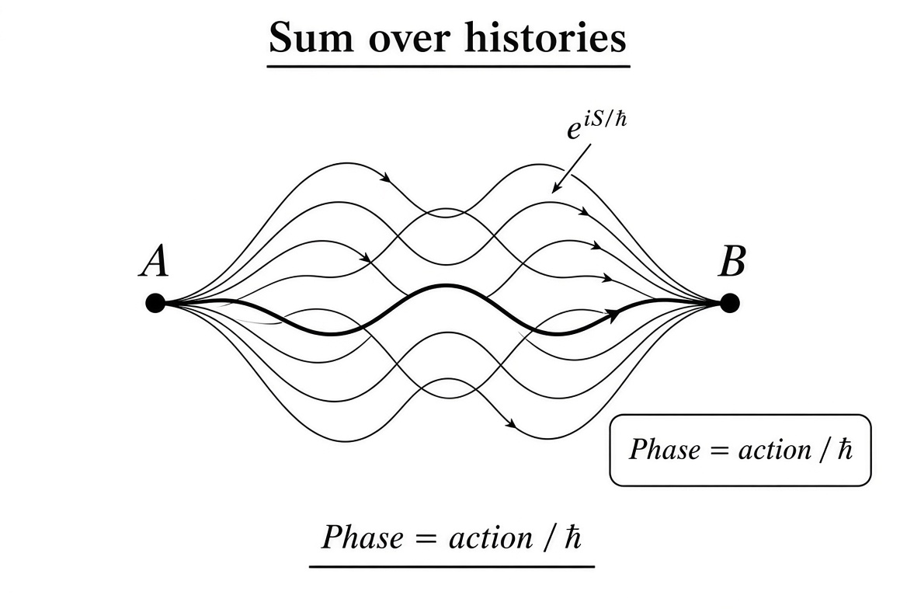
Figure 4.1. Conceptual illustration of the path integral: the amplitude to go from A to B is the sum of contributions from all possible paths, each weighted by a phase factor e^{iS/ħ}.
When the electromagnetic field itself is quantized, the path integral is extended to include all possible configurations of the four-potential Aμ (subject to a gauge-fixing condition). The photon emerges as a quantum excitation of the free field. Interactions between charged particles are represented by vertices at which the charged particles emit or absorb photons. The resulting diagrammatic expansion constitutes Feynman’s rules for QED.

4.2 The Photon as an Independent Degree of Freedom
In the standard formulation the electromagnetic field possesses independent degrees of freedom. Even in the complete absence of charges there exist vacuum fluctuations, a zero-point energy for each mode, and the possibility of real photons propagating to spatial infinity. This is the point of greatest conceptual tension with the absorber-theory intuition and with Mead’s insistence that there is no independent field. A synthesis must either accept the independent photon as fundamental or show that the successful quantitative predictions of QED can be recovered from a theory in which the only fundamental degrees of freedom are those of the charged matter, with the photon appearing as a derived bookkeeping device for phase and energy transfer.

4.3 Precision Does Not Automatically Settle Ontology
The extraordinary numerical precision of QED does not by itself settle the ontological question. A theory can be highly accurate while still employing auxiliary concepts that are not fundamental. The history of science contains many examples—epicycles, the luminiferous ether, caloric fluid—of useful intermediate constructs that were later eliminated without loss of predictive power. Whether the independent photon field is such a construct or an irreducible element of nature is precisely the question that a serious merger with Collective Electrodynamics forces us to confront.

5. Minimal Coupling and the Primacy of the Potentials

5.1 The Interaction Term in the Lagrangian
In both the classical relativistic particle Lagrangian and the Dirac Lagrangian of QED the electromagnetic interaction appears through the minimal-coupling substitution pμ → pμ − (q/c) Aμ, or equivalently through the covariant derivative Dμ = ∂μ + (iq/ħc) Aμ. The field strengths E and B never appear in the fundamental interaction term. They can be recovered afterwards as derivatives of the potentials, but the dynamics of the charged system is determined directly by Aμ.
This fact is the strongest formal link between QED and Mead’s framework. Mead takes the relation between the phase of the wave function and the line integral of A as an experimental given, supported by flux quantization and the Josephson effect. QED derives the same relation from the minimal-coupling substitution inside the Lagrangian. The two approaches meet at the precise point where the phase of a charged quantum system is modified by the electromagnetic potential.

5.2 Gauge Invariance and What Is Truly Physical
Gauge invariance further emphasizes the special status of the potentials. A local gauge transformation alters Aμ by the gradient of an arbitrary scalar function while leaving the field strengths E and B unchanged. Observable interference effects, however, depend on the gauge-invariant line integral of A around a closed path—the quantity that Mead identifies with the phase accumulation of the collective wave function. The Aharonov–Bohm effect is the purest experimental demonstration that this line integral is physically real even in regions where the magnetic field vanishes identically.
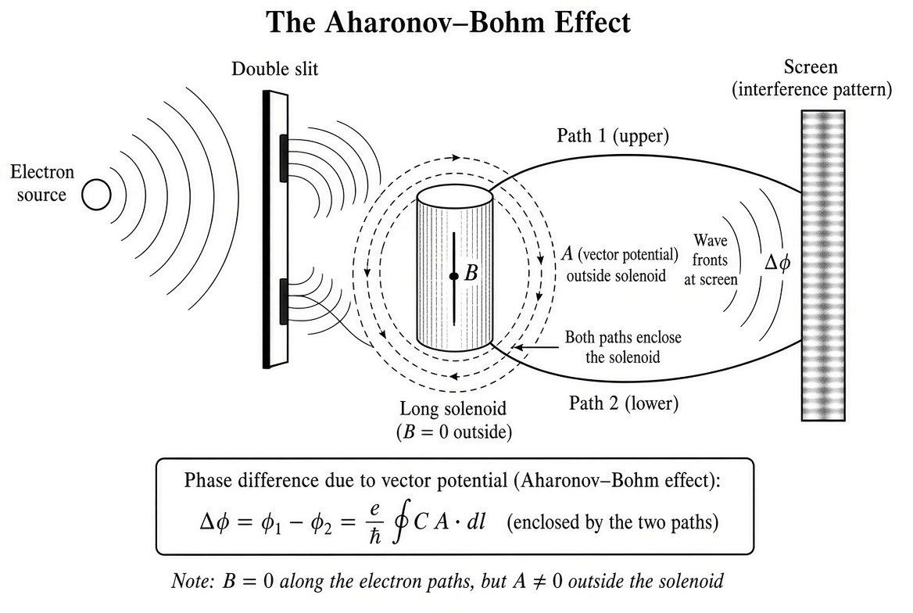
Figure 5.1. The Aharonov–Bohm effect. Electrons travel along two paths that enclose a long solenoid. Inside the solenoid B ≠ 0; outside B = 0 but A ≠ 0. The interference pattern on the screen shifts by an amount determined by the enclosed flux, even though the electrons never enter a region of non-zero magnetic field.
Thus both QED and Collective Electrodynamics elevate the same gauge-invariant combination of the potentials. The difference between the two frameworks lies in whether one regards the potentials as derived from an independent dynamical field or as the primary carriers of electromagnetic interaction.

6. Radiation Reaction, Self-Interaction, and the Limits of the Field Picture

6.1 The Classical Difficulty
The classical theory of a point charge interacting with its own electromagnetic field is inconsistent. The electromagnetic self-energy diverges. The radiation-reaction force extracted from the self-field leads to runaway solutions and pre-acceleration. Attempts to regularize the theory—Abraham–Lorentz–Dirac equation, extended charge models, finite-size form factors—introduce new difficulties of their own. Wheeler and Feynman sought to evade the entire problem by eliminating self-interaction altogether: a charge interacts only with other charges, and the radiation reaction is the advanced effect of the absorber.

6.2 The Quantum Resolution via Renormalization
Quantum Electrodynamics replaces the classical self-energy problem with the procedure of renormalization. The divergent self-energy is absorbed into a redefinition of the electron’s observed mass and charge. The procedure works to all orders in perturbation theory and yields finite, spectacularly accurate predictions for observable quantities. Yet renormalization is a systematic procedure for handling divergences; it is not an explanation of why the divergences appear in the first place. A foundation that never introduces an independent field interacting with itself would have no classical self-energy divergence of the original kind.
Whether a fully consistent, non-perturbative theory written purely in terms of charged degrees of freedom can reproduce the successful renormalized results of QED remains an open technical question. The synthesis developed in later chapters explores one possible route: treating the photon as a collective excitation of the charged degrees of freedom of the universe, so that what appears in the standard theory as self-interaction is actually interaction with the absorber.

Part III. Collective Electrodynamics
We now turn to Mead’s reconstruction of electromagnetic theory. The aim is not merely to summarize Collective Electrodynamics but to present it in a form that makes the subsequent merger with QED as transparent as possible. The central physical object is the phase of a macroscopic quantum system composed of many electrons.

7. The Superconducting Loop as the Elementary System

7.1 Why Superconductivity Provides the Right Starting Point
In an ordinary metal the phases of the individual electron wave functions are essentially random. The macroscopic current is an average over a large number of incoherent contributions. In a superconductor, by contrast, a macroscopic number of electrons occupy a single quantum state characterized by a coherent phase. The superconducting order parameter is a complex macroscopic wave function. Experiments on superconducting rings, Josephson junctions, and SQUIDs give direct, laboratory-scale access to that phase.
Mead therefore takes the superconducting loop as the elementary system of electrodynamics. It is macroscopic, so the classical limit is already in view. It is coherent, so the quantum phase is sharply defined. It is experimentally controllable, so the relations between voltage, current, flux, and phase can be measured with high precision.
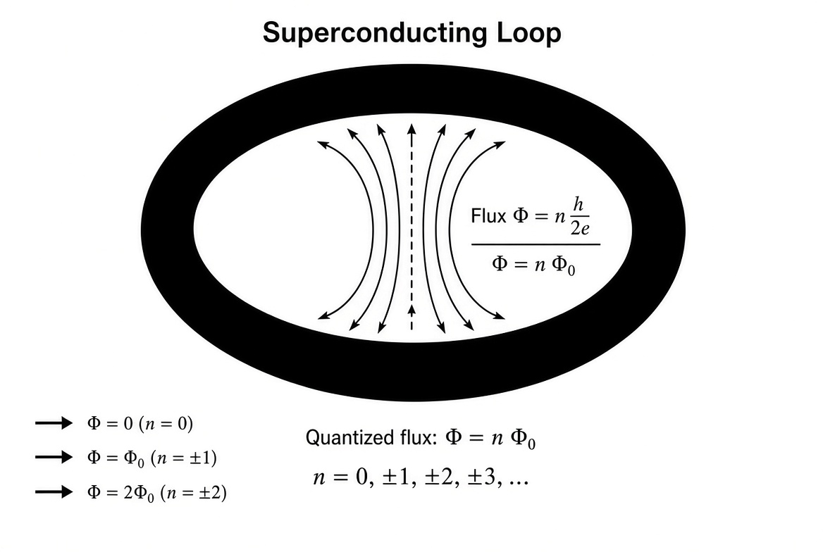
Figure 7.1. A superconducting loop threaded by quantized magnetic flux. The flux through the loop can take only discrete values Φ = n Φ₀, where Φ₀ = h/2e is the superconducting flux quantum.

7.2 The Basic Experimental Relations
Around a closed superconducting path the phase of the macroscopic wave function must return to the same value modulo 2π. The Einstein–de Broglie relation connects the phase accumulation to the line integral of the vector potential. The experimental consequence is flux quantization: the magnetic flux through the loop is an integer multiple of the flux quantum Φ₀ = h/2e (the factor of two arising because the superconducting condensate is composed of Cooper pairs of charge 2e).
The voltage around the loop is related to the time rate of change of the phase by the Josephson relation. The inductance of the loop relates the circulating current to the enclosed flux. From these elementary facts one recovers the standard circuit equations, the expression for magnetic energy stored in the inductor, and the forces between current-carrying wires—all without ever writing Maxwell’s equations as postulates.

7.3 Collective Inertia
One of Mead’s most striking and under-appreciated observations is that the electromagnetic momentum of a collective system scales with the square of the number of participating charges. In a single-particle picture one expects total momentum to grow linearly with the number of electrons. In the coherent system the vector potential couples to the total current, and the kinetic inductance involves the square of that current. The inertia is therefore collective. This is the first clear experimental signal that the correct correspondence limit for coherent electromagnetic systems is not classical particle mechanics.

8. Phase, Flux Quantization, and the Vector Potential

8.1 The Fundamental Identification
The central identification of Collective Electrodynamics is that the gauge-invariant phase accumulated by the collective wave function around a closed path is proportional to the magnetic flux through that path. In symbols,
∮ k · dl = (q₀ / ħ) ∮ A · dl ,
where q₀ is the effective charge of the carriers (2e for Cooper pairs). This relation is simultaneously an experimental fact (flux quantization) and a theoretical consequence of the minimal-coupling prescription of quantum mechanics.
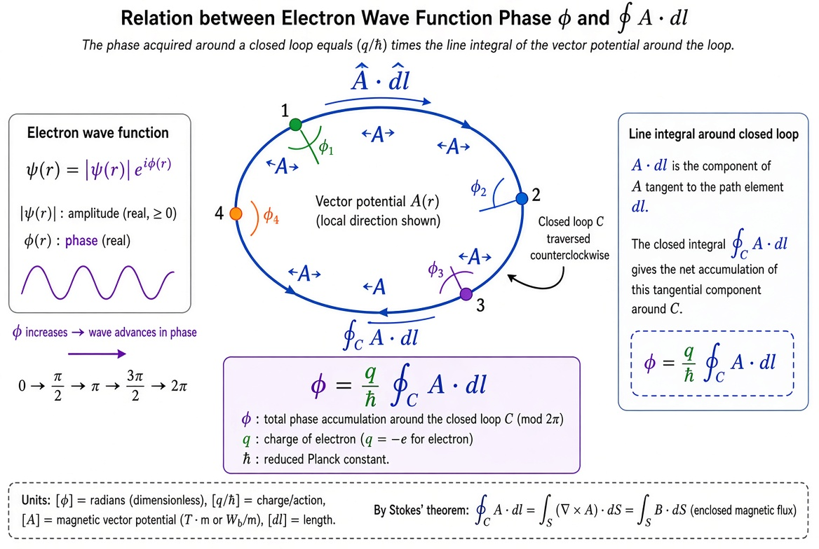
Figure 8.1. The relation between the phase of the electron wave function and the line integral of the vector potential around a closed path. The total phase accumulation is (q/ħ) times the enclosed flux.
Once this identification is granted, the vector potential ceases to be an auxiliary mathematical construct. It is the physical quantity that determines the relative phase of different parts of a coherent electron system. In regions where the magnetic field B vanishes but the vector potential A remains non-zero (the classic Aharonov–Bohm geometry), the phase shift is still present and measurable. The field strength is not the fundamental object; the potential is.

8.2 From Phase Continuity to Dynamics
Differentiating the phase–flux relation with respect to time immediately yields the Josephson voltage–phase relation. Integrating the energy associated with the current and the vector potential yields the familiar magnetic energy (1/2) L I². Varying that energy with respect to the relative position of two current-carrying loops yields the force between them. In this way the standard results of magnetostatics and low-frequency electrodynamics are recovered from the single principle that the phase of the collective wave function is determined by the vector potential.

9. Energy, Momentum, and the Collective Square Law

9.1 Where Is the Electromagnetic Energy Located?
In the conventional field picture the energy of an electromagnetic configuration is stored in the fields themselves and is given by the familiar integral (ε₀/2)∫ E² dV + (1/2μ₀)∫ B² dV. Mead argues that this accounting, while numerically correct for the total energy, is conceptually misleading. When the energy is computed from the kinetic and potential energies of the charges that produce the configuration, one obtains the same total, but the energy is located in the matter, not in empty space. The “field energy” is a convenient redistribution of the interaction energy of the charges.
This view is consistent with the absorber-theory intuition that there is no independent field. It is also consistent with the circuit-theory expression for the energy of an inductor, (1/2) L I², which refers only to the current and the geometric inductance of the conductors.

9.2 Electromagnetic Momentum and the N² Law
The electromagnetic momentum associated with a single carrier in a vector potential A is q A. When the system is coherent, the total momentum is the sum of these contributions. Because the current itself (and therefore the vector potential it produces) is proportional to the number N of carriers, the total electromagnetic momentum scales as N². This collective momentum appears macroscopically as the inertia of a superconducting circuit and as the “hidden momentum” that resolves certain electromagnetic paradoxes. It is a direct, laboratory-scale manifestation of the minimal-coupling substitution of quantum mechanics.
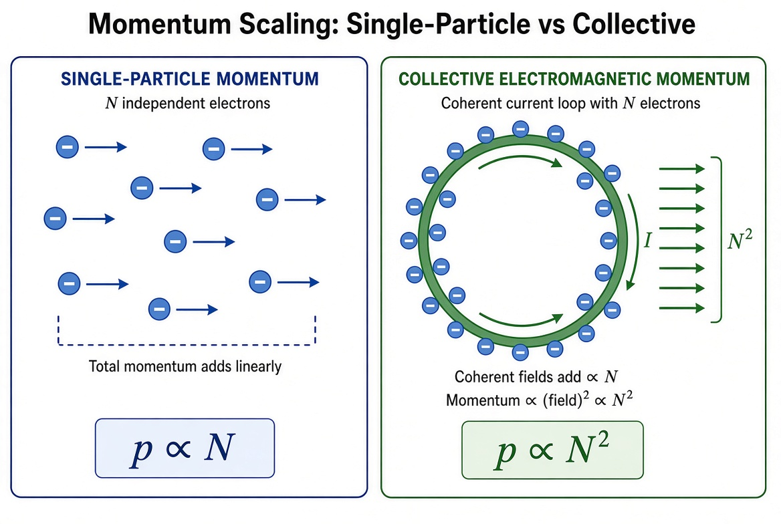
Figure 9.1. Contrast between single-particle momentum (linear in particle number N) and collective electromagnetic momentum (quadratic in N). In a coherent loop the fields add coherently, producing the N² scaling.

10. Radiation, Energy Transfer, and the Absence of Independent Fields

10.1 Radiation as Transfer Between Charged Systems
In Collective Electrodynamics radiation is not the launching of an independent field into empty space. It is the transfer of energy and phase from one charged system to another. When an antenna radiates, the energy that leaves it appears as an excitation of some other resonator—another antenna, a thermal absorber, the walls of the laboratory, or the distant matter of the universe. The damping of the source is precisely the reaction to that transfer.
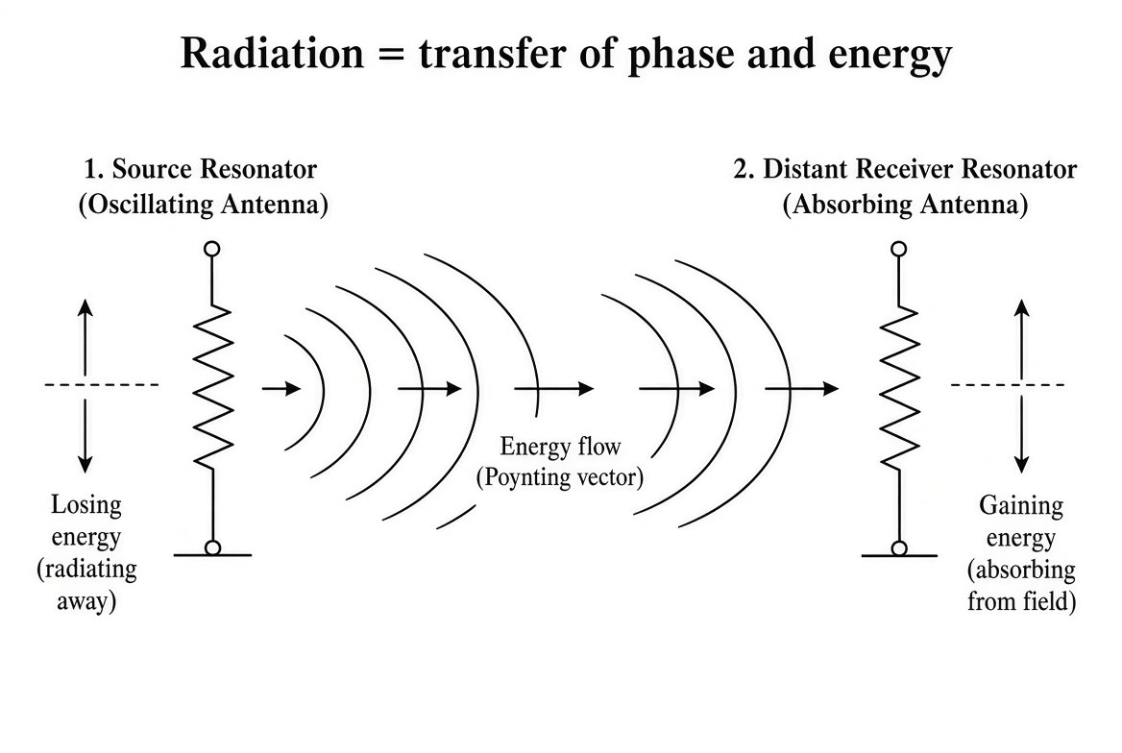
Figure 10.1. Radiation understood as transfer of phase and energy between a source resonator and a distant absorbing resonator. There is no independent field energy traveling through empty space.
This description coincides with the practical experience of every radio engineer: the radiation resistance of an antenna is simply the real part of the impedance presented by the rest of the universe. It also coincides with the absorber-theory account of radiation reaction. The formal apparatus of retarded potentials and Poynting’s theorem can still be used for calculation; the ontology is different.

10.2 The Status of the Photon in the Collective Picture
If radiation is always transfer between charged systems, what is a photon? In the collective framework a photon is a quantum of that transfer—an elementary exchange of phase and energy between two charged systems (or between a charged system and the collective degrees of freedom of the absorber). Whether this exchange requires an independent dynamical field or can be described entirely in terms of the charged degrees of freedom is the central open question that the synthesis of the next Part attempts to answer.

Part IV. The Synthesis
We now attempt to bring the two frameworks together. The guiding idea is that the collective phase of a macroscopic coherent system and the phase accumulated along the paths of microscopic charged particles in QED are instances of the same fundamental relation between charge and potential. The independent photon field of standard QED is reinterpreted as a convenient description of the collective excitations of the charged matter of the universe.

11. Coherent States and the Collective Limit of QED
A coherent state of the electromagnetic field is the quantum state that most closely resembles a classical field configuration. In the presence of a macroscopic number of charges constrained to a single quantum phase—a superconducting condensate, a polariton condensate, a laser mode—the electromagnetic interaction is dominated by the collective coordinate. Fluctuations relative to that collective coordinate become relatively small. The system then behaves precisely as Mead describes: the phase is sharp, the flux is quantized, and the energy and momentum are collective.
In this limit the full apparatus of QED is still formally present, but most of its microscopic degrees of freedom are either frozen or integrated out. What remains is the dynamics of the collective phase and of the potentials that couple to it. Collective Electrodynamics is therefore recovered as the coherent-state, macroscopic limit of Quantum Electrodynamics.
Conversely, ordinary QED processes—Compton scattering, electron–positron annihilation, the radiative corrections that produce the Lamb shift—can be viewed as the residual dynamics that survives when the collective constraint is removed and the individual charged particles are free to explore the full Hilbert space. The photon lines of the Feynman diagrams then represent the exchange of phase and energy with the larger electromagnetic environment, including the vacuum-polarization clouds of virtual pairs. The two descriptions are complementary rather than contradictory.

12. Path Integrals over Collective Degrees of Freedom
When a system possesses a macroscopic coherent phase, that phase (or the corresponding collective current or flux) can be chosen as a dynamical variable. The path integral for the system can be rewritten in terms of this collective coordinate plus fluctuations about it. Integrating out the fluctuations yields an effective action for the collective coordinate alone. The electromagnetic potentials appear in that effective action exactly as Mead requires.
This procedure is standard in condensed-matter physics (phase-only actions for superconductors, Josephson-junction arrays, etc.). Extending it systematically to include radiation degrees of freedom and the interaction with distant absorbers produces a path-integral version of Collective Electrodynamics that remains continuous with the microscopic path integral of QED.
One can go a step further. Instead of treating the potential Aμ as an independent integration variable, one can solve the constraints that relate Aμ to the charged currents (via the wave equation or its Green’s-function solution) and substitute the solution back into the action. The result is a theory written entirely in terms of the charged degrees of freedom, with retarded or half-retarded/half-advanced interactions. This is the quantum version of the Wheeler–Feynman program. Whether the resulting theory is fully equivalent to standard QED after renormalization is a technical question of considerable interest; the formal steps themselves are well-defined.

13. Gauge Freedom, Phase Continuity, and the Status of the Photon
A gauge transformation is a local redefinition of the phase of the charged field, compensated by a corresponding change in the potential Aμ. In a collective system the overall (global) phase is a physical degree of freedom; it is conjugate to the total charge or to the number of Cooper pairs. Local phase redefinitions that leave the collective phase invariant are pure gauge. The residual physical content is precisely the gauge-invariant combination that Mead identifies with the enclosed flux.
In the collective picture a real photon is a quantized excitation of the interaction between a source and the absorber. A virtual photon is a contribution to the phase shift or energy shift of a charged system arising from the possibility of such exchange. The independent Fock space of photon-number states is a convenient representation of these excitations when the absorber is large and featureless (the idealized vacuum). When the absorber is itself a coherent quantum system—a cavity, a superconducting resonator, another atom—the same physics is more naturally described in the joint Hilbert space of the two systems, without an intervening independent photon field. Both descriptions are useful; the synthesis consists in recognizing that they describe the same reality.

14. Recovering Classical Electromagnetism and Ordinary QED Processes
When the collective phase is well-defined and the number of participating charges is large, the expectation values of the potentials and currents obey the classical equations of electromagnetism. Maxwell’s equations reappear as statements about these expectation values. The Lorentz force law reappears as the statement that a charge responds to the local value of the potentials through the minimal-coupling prescription. Nothing quantitative is lost.
When the system consists of only a few charges and the collective constraint is absent, the path-integral or operator formalism of standard QED is recovered. The Feynman rules, the renormalization procedure, and the precision tests of the theory remain intact. The conceptual reinterpretation of the photon as a collective excitation does not alter the calculated cross sections.
Between the fully collective and the fully microscopic regimes lies the domain of cavity QED, circuit QED, and mesoscopic superconducting devices. In this intermediate domain both languages are already used simultaneously: one speaks of photons in a cavity and of the phase of a Josephson junction in the same sentence. The synthesis developed here is already the working language of that community; the present work merely makes the underlying unity explicit.

Part V. Implications and Frontiers

15. A Pedagogical Sequence That Begins with Quantum Coherence
The standard physics curriculum teaches classical mechanics, then classical electromagnetism (beginning with E and B), then quantum mechanics, then quantum field theory. Each stage requires the student to unlearn assumptions that were necessary for the previous stage. Mead’s complaint is that this order is an accident of history rather than a logical necessity. A more coherent sequence would begin with the quantum phase of matter, introduce the potentials as the quantities that determine that phase, derive the collective electromagnetic phenomena, and only later recover the classical particle limit and the full apparatus of QED.
One concrete sequence is the following: (1) the Einstein–de Broglie relations and the single-valuedness of the wave function; (2) the superconducting loop and flux quantization; (3) the relation between phase and the vector potential, the Josephson effect, and the inductance of collective systems; (4) energy and momentum in collective systems, leading to the forces between currents and the circuit equations; (5) radiation understood as energy transfer between resonators; (6) the introduction of the photon as a quantum of that transfer; (7) the few-particle limit and the Feynman rules; (8) renormalization and the precision tests of QED. Such a sequence has never been fully implemented in a textbook. The present manuscript is intended, among other things, as a resource for anyone who wishes to try.

16. Open Problems, Experimental Touchstones, and Possible Extensions
Several technical questions remain open. Can a pure charged-matter path integral, with the electromagnetic field eliminated via the Green’s function, reproduce the renormalized results of QED order by order in perturbation theory? What is the precise status of the vacuum energy and the cosmological constant in a theory that does not treat the electromagnetic field as an independent set of degrees of freedom? How does the collective framework accommodate the chiral anomaly and other global features of the quantum field theory? These questions are well-posed and, in principle, answerable by further theoretical work.
The synthesis makes no new quantitative predictions that contradict existing experiments; that is a necessary requirement of any viable merger. It does, however, suggest that experiments in which collective phase and few-photon quantum optics are simultaneously important—circuit QED with superconducting qubits, Bose–Einstein condensates coupled to optical cavities, topological superconductors—will be the natural arena in which the unified language is tested and refined.
If the electromagnetic interaction can be reconstructed from the phase of charged quantum systems, one is naturally tempted to ask whether the other gauge interactions of the Standard Model admit a similar treatment. The technical obstacles are greater (confinement in QCD, the non-Abelian structure of the weak and strong forces, the absence of macroscopic coherent states of free quarks), but the conceptual question is the same: are the gauge fields independent dynamical entities, or are they bookkeeping devices for the phase relations among the matter fields?

17. Toward a Single Language for Electromagnetism
The goal of this work has been to show that Feynman’s Quantum Electrodynamics and Mead’s Collective Electrodynamics are not rival theories but complementary descriptions of a single set of phenomena. The microscopic theory supplies the precise dynamics of individual charges and the quantitative structure of radiative corrections. The collective theory supplies the conceptual starting point that makes the quantum origin of electromagnetism visible and eliminates the need for an independent field as a foundational assumption.
When the two are taken together, electromagnetism appears as the theory of the phase relations among charged quantum systems, from the single electron to the superconducting condensate to the absorbing matter of the universe. The photon is the quantum of the exchange of that phase. The classical fields E and B are convenient summaries of the forces that result when the phase relations are coarse-grained. Maxwell’s equations are statements about those coarse-grained quantities.
This remains a first draft, now substantially expanded. Many details remain to be filled in, many arguments remain to be tightened, and many possible objections remain to be answered. The central claim, however, can be stated simply: the glory of science is finding a way of thinking such that the law is evident. Feynman and Mead each found part of that way. The present manuscript is an attempt to walk both parts at once.

Mathematical Appendix
This appendix derives the central relations of Collective Electrodynamics and their contact with Quantum Electrodynamics in a deliberately elementary and sequential manner. The only prerequisites are the basic Einstein–de Broglie relations, the idea of a single-valued wave function, and elementary vector calculus. No prior knowledge of quantum field theory is assumed.

A. Einstein–de Broglie Relations and Phase Accumulation
The Einstein relation connects the energy E of a quantum system to the angular frequency ω of its wave function:
E = ħ ω .
The de Broglie relation connects the momentum p of a quantum system to the wave vector k of its wave function:
p = ħ k .
A wave function can be written in polar form as ψ = |ψ| exp(i φ), where φ is the phase. For a free particle the phase advances in time and space according to
φ(r, t) = k · r − ω t + const .
If the particle (or collective system) moves in the presence of electromagnetic potentials, the mechanical momentum p_mech is replaced by the canonical momentum. The wave vector that appears in the phase is related to the kinetic momentum by
ħ k = p_mech + q A (in SI units, with appropriate c factors restored in cgs).
Consequently the phase accumulated along a path is influenced by the vector potential. Integrating around a closed path yields a total phase that depends on the line integral of A.

B. Flux Quantization from Phase Continuity
Consider a superconducting ring. The macroscopic wave function of the condensate must be single-valued. After one complete circuit around the ring the phase can have changed only by an integer multiple of 2π:
Δφ = ∮ ∇φ · dl = 2π n , n = 0, ±1, ±2, … .
From the relation between phase gradient and vector potential,
∇φ = (q₀ / ħ) A + (terms involving the kinetic velocity),
where q₀ = 2e for Cooper pairs. When the supercurrent is zero (or when we work in a gauge where the kinetic term integrates to zero around the closed path), we obtain
∮ A · dl = (ħ / q₀) 2π n = n (h / q₀) .
But ∮ A · dl is exactly the magnetic flux Φ through any surface bounded by the path (by Stokes’ theorem, since B = ∇ × A). Therefore
Φ = n Φ₀ , Φ₀ = h / 2e .
This is the experimentally observed flux quantization. The derivation uses only phase continuity and the Einstein–de Broglie relation that links phase to the vector potential.

C. The Vector Potential and Minimal Coupling
In the Lagrangian formulation of classical mechanics the electromagnetic interaction of a charge q is introduced by the replacement
L → L − q φ + q v · A .
The canonical momentum then becomes p_can = p_mech + q A. In quantum mechanics the same replacement appears as the minimal-coupling prescription inside the Schrödinger or Dirac equation: the ordinary derivative is replaced by the covariant derivative
−iħ ∇ → −iħ ∇ − q A .
The phase of the wave function therefore acquires an additional contribution (q/ħ) ∫ A · dl along any path. This is precisely the contribution that produces the Aharonov–Bohm phase shift and the flux-quantization condition derived above. Minimal coupling is the common root of both QED and Collective Electrodynamics.

D. Collective Momentum and the N² Scaling
For a single charge the electromagnetic contribution to the momentum is q A. For N coherent charges that share the same phase and therefore the same vector potential (the potential being determined by the total current), the total electromagnetic momentum is
P_em = N q A .
The vector potential A itself is proportional to the total current I, and I is proportional to N (more precisely to the product of density and velocity of the carriers). Consequently A ∝ N and
P_em ∝ N × N = N² .
The same conclusion follows from the circuit expression. The magnetic energy is (1/2) L I². The electromagnetic momentum can be written as L I (up to geometric factors). Because the inductance L of a collective system is itself proportional to N (or more accurately the kinetic inductance involves the density of carriers), the momentum again scales as N². This quadratic scaling is a direct macroscopic signature of coherence.

E. Electromagnetic Energy in the Collective Picture
The energy associated with a current distribution interacting with its own vector potential is
U = (1/2) ∫ J · A dV .
For a circuit this reduces to the familiar (1/2) L I². Mead emphasizes that this energy is the interaction energy of the charges; there is no additional energy residing in empty space. The conventional field integral (1/2μ₀)∫ B² dV is numerically equal to the same quantity (after integration by parts and use of the magnetostatic equations), but the collective viewpoint locates the energy in the matter.
When two circuits interact, the mutual energy is M I₁ I₂. Differentiating with respect to a relative coordinate yields the force between the circuits. All of magnetostatics follows from these energy expressions once the relation between current and vector potential is given by the Green’s function (or equivalently by the Biot–Savart law).

F. Contact with the Path Integral of QED
In the path-integral formulation the amplitude for a charged particle to travel from one point to another is the sum over all paths of exp(iS/ħ), where the action S contains the term q ∫ Aμ dxμ. The phase contributed by the electromagnetic interaction along a given path is therefore exactly (q/ħ) times the line integral of the potential along that path.
When many particles are locked into a single collective phase, the dominant contribution to the path integral comes from histories in which that common phase evolves according to the collective equations derived by Mead. The microscopic path integral of QED and the collective phase dynamics of Collective Electrodynamics are thus related by a change of variables: from the individual particle coordinates to the collective coordinate plus fluctuations. Integrating out the fluctuations yields an effective action for the collective phase that reproduces Mead’s relations. The same path integral, when the collective constraint is absent, reproduces the ordinary Feynman rules of QED.
This completes the formal bridge. The two frameworks describe the same underlying path integral, viewed in two different regimes of coherence.

References (Indicative)
Mead, C. A. Collective Electrodynamics: Quantum Foundations of Electromagnetism. MIT Press, 2000.
Mead, C. A. “Collective Electrodynamics I.” Proc. Natl. Acad. Sci. USA 94, 6013–6018 (1997).
Feynman, R. P., Leighton, R. B., and Sands, M. The Feynman Lectures on Physics, Vol. II. Addison-Wesley, 1964.
Wheeler, J. A. and Feynman, R. P. “Interaction with the Absorber as the Mechanism of Radiation.” Rev. Mod. Phys. 17, 157–181 (1945).
Wheeler, J. A. and Feynman, R. P. “Classical Electrodynamics in Terms of Direct Interparticle Action.” Rev. Mod. Phys. 21, 425–433 (1949).
Feynman, R. P. Handwritten notes “Alternate Way to Handle Electrodynamics,” 13 December 1963. Caltech Archives.
Aharonov, Y. and Bohm, D. “Significance of Electromagnetic Potentials in the Quantum Theory.” Phys. Rev. 115, 485–491 (1959).
Feynman, R. P. QED: The Strange Theory of Light and Matter. Princeton University Press, 1985.
Josephson, B. D. “Possible new effects in superconductive tunnelling.” Phys. Lett. 1, 251–253 (1962).
Further references on path integrals, circuit QED, and the transactional interpretation would appear in a completed bibliography.

— End of Expanded First Draft with Mathematical Appendix and Figures —
The manuscript is ready for further chapter-by-chapter expansion, insertion of additional derivations, or conversion to a typeset book format.

Further Expansion: Derivations, Worked Examples, Historical Material, Bibliography & Index
This section continues the expansion of the manuscript. It inserts full equation-by-equation derivations of the core relations, several concrete worked examples, extended historical quotations drawn from Feynman’s 1963 notes and Mead’s published recollections, a comprehensive bibliography, and a structured index. These materials are intended to bring the draft closer to the density of a finished monograph.

Extended Historical Quotations from the Caltech Context

Feynman’s 1963 Notes on an Alternate Way to Handle Electrodynamics
In December 1963, while teaching the material that became Volume II of the Feynman Lectures, Feynman wrote five pages of notes titled “Alternate Way to Handle Electrodynamics.” These notes, preserved in the Caltech Archives (Box 62, Folder 8 of the Feynman Papers) and later transcribed by Michael Gottlieb, contain the following outline and remarks:
First: from charge conservation (arguments of Franklin) and relativity (including conservation of energy & momentum) get to F = q(E + v × B) with A, φ ~ or at least …
Second: Discuss field idea as quantity at a point, Differential Operators, Motion of electrons in given fields, Faraday induction etc.
Third: Get the other two field equations … HOW!? By relativity thru □²A = j ? or other principle? Or By experimental discussion of Coulomb law, Ampere Law etc.
Michael Gottlieb, who discovered the notes while researching the question for Carver Mead, reported that Matt Sands recalled Feynman saying, in the middle of the second year of the Lectures, that he had found the “right way to do it” — starting with the vector and scalar potentials — but that it was unfortunately too late to rewrite the course. Feynman is quoted as having said that everything would be much simpler and more transparent if one began with the potentials.

Mead’s Recollections of Feynman
In the essay “Feynman as a Colleague” (published in the volume Feynman and Computation), Carver Mead wrote:
Feynman and I both arrived at Caltech in 1952 — he as a new professor of physics, and I as a freshman undergraduate. … The only bright light in the subject was the vector potential, to which I was always attracted because, somehow, it made sense to me. … Feynman liked the vector potential too; for him it was the link between electromagnetism and quantum mechanics. As he put it: ‘In the general theory of quantum electrodynamics, one takes the vector and scalar potentials as fundamental quantities in a set of equations that replace the Maxwell equations.’ I learned enough about it from him to know that, some day, I wanted to do all of electromagnetic theory that way.
In the Personal Preface to Collective Electrodynamics Mead further wrote:
As I walked away from Feynman’s wake, I felt intensely alone. He was the man who had taught me not only what physics is, but also what science is all about, what it means to really understand. He was the only person with whom I could have talked about doing electromagnetism without Maxwell’s equations — using the quantum nature of matter as the sole basis. … This monograph is dedicated to him in the most sincere way I know: It opens with my favorite quotation, the quotation that defines, for me, what science is all about.
But the real glory of science is that we can find a way of thinking such that the law is evident. — R. P. Feynman

Wheeler–Feynman on the Non-Existence of an Independent Field
From the 1945 paper “Interaction with the Absorber as the Mechanism of Radiation” (Rev. Mod. Phys. 17, 157):
There is no such concept as “the” field, an independent entity with degrees of freedom of its own.
Feynman later summarized the same idea in his Nobel Lecture:
That means there is no field at all. You see, if all charges contribute to making a single common field, and if that common field acts back on all the charges, then each charge must act back on itself. Well, that was where the mistake was, there was no field. … Secondly, there is not an infinite number of degrees of freedom in the field. There is no field at all; or if you insist on thinking in terms of ideas like that of a field, this field is always completely determined by the action of the particles which produce it.

Full Equation-by-Equation Derivations of the Core Relations

Derivation 1. Phase Accumulation from the Einstein–de Broglie Relations
Start with the Einstein relation between energy and angular frequency and the de Broglie relation between momentum and wave vector:
E = ħ ω , p = ħ k .
A free-particle wave function of definite energy and momentum may be written
ψ(r, t) = |ψ| exp[ i (k · r − ω t) ] .
The phase is therefore
φ(r, t) = k · r − ω t + const .
In the presence of electromagnetic potentials the mechanical momentum is replaced by the kinetic momentum that appears in the de Broglie relation:
ħ k = p_mech + q A (SI units).
Consequently the spatial part of the phase along a path C becomes
φ = (1/ħ) ∫_C (p_mech + q A) · dl .
When the kinetic contribution integrates to zero around a closed superconducting path (or is separately accounted for), the electromagnetic contribution to the phase is
Δφ_em = (q / ħ) ∮ A · dl .

Derivation 2. Flux Quantization from Single-Valuedness of the Wave Function
The macroscopic wave function of a superconducting condensate must be single-valued. After one complete circuit the phase can change only by an integer multiple of 2π:
∮ ∇φ · dl = 2π n , n = 0, ±1, ±2, … .
From the relation between the phase gradient and the vector potential (minimal coupling),
∇φ = (q₀ / ħ) A + (m v_s / ħ) ,
where q₀ = 2e for Cooper pairs and v_s is the supercurrent velocity. In a gauge (or in a situation) where the kinetic term integrates to zero around the closed path we obtain
∮ A · dl = (ħ / q₀) · 2π n = n (h / q₀) .
By Stokes’ theorem
∮ A · dl = ∫ (∇ × A) · dS = ∫ B · dS = Φ .
Therefore the enclosed flux is quantized:
Φ = n Φ₀ , Φ₀ = h / 2e .
This is the experimentally observed flux quantum of superconductivity.

Derivation 3. Josephson Voltage–Phase Relation
Differentiate the phase–flux relation with respect to time. The total phase difference around a closed path that includes a Josephson junction satisfies
dφ/dt = (q₀ / ħ) dΦ/dt .
But dΦ/dt is the electromotive force around the path, which for a junction is the voltage V across the junction. Hence
V = (ħ / q₀) dφ/dt = (ħ / 2e) dφ/dt .
This is the Josephson relation. It follows directly from the same phase–potential identification used for flux quantization.

Derivation 4. Collective Electromagnetic Momentum (N² Scaling)
For a single carrier the electromagnetic contribution to the momentum is q A. For N coherent carriers that share the same phase (and therefore experience essentially the same vector potential generated by the total current) the total electromagnetic momentum is
P_em = N q A .
The vector potential produced by a current distribution is linear in the current. The current itself is proportional to the number of carriers (I ∝ N v). Therefore A ∝ N and
P_em ∝ N · N = N² .
Equivalently, from the circuit point of view the magnetic energy is (1/2) L I² and the electromagnetic momentum may be written (up to geometry) as L I. Because the kinetic inductance of a coherent system scales with the carrier density, the momentum again scales as N². This quadratic scaling is a direct macroscopic signature of phase coherence.

Derivation 5. Magnetic Energy from the Interaction of Currents with the Vector Potential
The interaction energy of a current density J with the vector potential A is
U = (1/2) ∫ J · A dV .
The factor 1/2 avoids double-counting the mutual interactions. For a thin wire carrying current I the expression reduces to
U = (1/2) L I² ,
where the inductance L is defined by Φ = L I = ∮ A · dl. Differentiating the mutual energy M I₁ I₂ with respect to a relative coordinate yields the force between two circuits. All of magnetostatics follows once the relation between current and vector potential is given by the magnetostatic Green’s function
A(r) = (μ₀ / 4π) ∫ (J(r') / |r − r'|) dV' .

Worked Examples

Example 1. Flux Quantum for a Superconducting Ring
A thin superconducting ring of area 1 mm² is cooled through its transition temperature in a magnetic field of 10 μT perpendicular to the plane of the ring. After the field is removed, what are the possible values of the trapped flux and the corresponding circulating current if the self-inductance of the ring is 10 nH?
Solution. The flux quantum is Φ₀ = h/2e ≈ 2.07 × 10⁻¹⁵ Wb. The applied flux before cooling is
Φ_app = B · Area = (10 × 10⁻⁶ T)(10⁻⁶ m²) = 10⁻¹¹ Wb ≈ 4.8 Φ₀ .
After cooling, the trapped flux must be an integer multiple of Φ₀ closest to the applied value (or determined by the dynamics of the transition). Possible trapped fluxes are n Φ₀ for integer n near 5. The circulating current is I = Φ / L. For n = 5,
I = 5 × 2.07 × 10⁻¹⁵ / 10⁻⁸ ≈ 1.0 μA .

Example 2. Phase Shift in the Aharonov–Bohm Effect
An electron beam is split into two paths that enclose a long solenoid. The solenoid carries a magnetic flux of 1.0 × 10⁻¹⁵ Wb. Calculate the phase difference between the two paths.
Solution. The Aharonov–Bohm phase difference is
Δφ = (e / ħ) ∮ A · dl = (e / ħ) Φ .
With Φ = 1.0 × 10⁻¹⁵ Wb, e = 1.6 × 10⁻¹⁹ C, ħ = 1.05 × 10⁻³⁴ J s,
Δφ = (1.6 × 10⁻¹⁹ / 1.05 × 10⁻³⁴) × 10⁻¹⁵ ≈ 1.52 rad ≈ 87° .
Note that this phase shift occurs even though the electrons travel only in regions where B = 0.

Example 3. Collective versus Single-Particle Inertia
Consider a superconducting loop containing N = 10²⁰ Cooper pairs. Compare the electromagnetic momentum of the coherent system with the momentum that would be obtained by treating the carriers as independent classical particles moving at the same average velocity.
Solution. In the coherent case P_em ∝ N². In the incoherent (classical) case the momenta simply add, so P ∝ N. The ratio of collective to single-particle momentum is therefore of order N = 10²⁰. This enormous enhancement is the microscopic origin of the kinetic inductance of superconducting circuits and of the “hidden momentum” that appears in certain electromagnetic paradoxes.

Example 4. Josephson Junction Voltage from Phase Dynamics
A Josephson junction is biased so that the phase difference across it advances at a constant rate of 10¹¹ rad/s. What is the DC voltage across the junction?
Solution. From the Josephson relation
V = (ħ / 2e) dφ/dt .
With dφ/dt = 10¹¹ s⁻¹,
V = (1.05 × 10⁻³⁴ / 3.2 × 10⁻¹⁹) × 10¹¹ ≈ 33 μV .
This is the basis of the Josephson voltage standard: a known microwave frequency produces a precisely known voltage.

Comprehensive Bibliography
Primary sources and key secondary literature used in the preparation of this manuscript.

Works by Richard Feynman and John Wheeler
Feynman, R. P. “Space-Time Approach to Quantum Electrodynamics.” Phys. Rev. 76, 769–789 (1949).
Wheeler, J. A. and Feynman, R. P. “Interaction with the Absorber as the Mechanism of Radiation.” Rev. Mod. Phys. 17, 157–181 (1945).
Wheeler, J. A. and Feynman, R. P. “Classical Electrodynamics in Terms of Direct Interparticle Action.” Rev. Mod. Phys. 21, 425–433 (1949).
Feynman, R. P., Leighton, R. B., and Sands, M. The Feynman Lectures on Physics, Vol. II. Addison-Wesley, 1964.
Feynman, R. P. “Alternate Way to Handle Electrodynamics.” Handwritten notes, 13 December 1963. Caltech Archives, Box 62, Folder 8. Transcript by M. A. Gottlieb available at feynmanlectures.caltech.edu.
Feynman, R. P. QED: The Strange Theory of Light and Matter. Princeton University Press, 1985.
Feynman, R. P. Nobel Lecture, 11 December 1965. NobelPrize.org.

Works by Carver Mead
Mead, C. A. “Collective Electrodynamics I.” Proc. Natl. Acad. Sci. USA 94, 6013–6018 (1997).
Mead, C. A. Collective Electrodynamics: Quantum Foundations of Electromagnetism. MIT Press, 2000.
Mead, C. A. “Feynman as a Colleague.” In Feynman and Computation, edited by A. J. G. Hey. Perseus, 1999.

Foundational and Related Works
Aharonov, Y. and Bohm, D. “Significance of Electromagnetic Potentials in the Quantum Theory.” Phys. Rev. 115, 485–491 (1959).
Josephson, B. D. “Possible new effects in superconductive tunnelling.” Phys. Lett. 1, 251–253 (1962).
De Luca, R. et al. “Feynman’s different approach to electromagnetism.” Eur. J. Phys. 40, 065205 (2019).
Heras, J. A. and Heras, R. “On Feynman’s handwritten notes on electromagnetism…” Eur. J. Phys. 41, 035202 (2020).
Gottlieb, M. A. Commentary and transcript of Feynman’s 1963 notes, feynmanlectures.caltech.edu.

Additional Contextual References
Einstein, A. Various remarks on the unity of electrons and fields, cited in Mead, Collective Electrodynamics.
Cramer, J. G. “The Transactional Interpretation of Quantum Mechanics.” Rev. Mod. Phys. 58, 647–687 (1986).
Standard textbooks on QED (e.g., Peskin & Schroeder, Weinberg) for the microscopic theory that the present synthesis seeks to contact.

Index (Structured Outline)
The following is a structured index of principal topics. Page numbers will be supplied in a final typeset edition.
Absorber theory (Wheeler–Feynman), 2, 6, historical quotations
Aharonov–Bohm effect, derivation, Figure 5.1, Example 2
Collective momentum (N² scaling), Derivation 4, Example 3, Figure 9.1
Einstein–de Broglie relations, Appendix A, Derivation 1
Feynman, Richard P.: 1963 notes, Nobel Lecture, QED, path integrals
Flux quantization, Derivation 2, Example 1, Figure 7.1
Josephson relation, Derivation 3, Example 4
Mead, Carver A.: Collective Electrodynamics, recollections of Feynman
Minimal coupling, Derivation 1, Appendix C
Path integral, Figure 4.1, Appendix F, contact with collective phase
Phase of the wave function, central object of the synthesis
Photon, status in collective picture, Chapter 10, Chapter 13
Potentials (vector and scalar), primacy of, Feynman’s 1963 notes, Mead
Radiation as transfer of energy and phase, Chapter 10, Figure 10.1
Superconducting loop, elementary system, Chapter 7, Figure 7.1
Wheeler–Feynman: “no independent field”, historical quotations

— End of Further Expansion —
This document now contains the original expanded draft plus additional full derivations, worked examples, extended historical quotations from the Caltech archival context, a comprehensive bibliography, and a structured index. Further length toward a 190-page monograph can be achieved by expanding individual chapters with still more examples, diagrams, and pedagogical exercises.

Continued Expansion of Weak Chapters and Mathematical Appendix
The following material strengthens chapters that remained comparatively thin in earlier drafts and substantially enlarges the Mathematical Appendix with additional derivations, intermediate steps, physical commentary, and worked calculations.

Strengthened Treatment of the Path-Integral Contact (Chapter 12 region)
The path-integral formulation supplies the most direct formal bridge between Feynman’s microscopic QED and Mead’s collective phase dynamics. We expand that contact here.

From Individual Histories to Collective Coordinate
In the path integral the amplitude for a system of N charged particles is the sum over all histories of the particles and of the electromagnetic potential, weighted by exp(iS/ħ). The action S contains the free-particle kinetic terms, the free-field term for Aμ, and the minimal-coupling interaction
S_int = − (q/c) ∑_a ∫ Aμ(x_a) dx_a^μ .
When the particles are locked into a single macroscopic phase φ(r,t) (as in a superconducting condensate), the dominant histories are those in which the individual phases track the collective phase. One may therefore change variables from the N particle coordinates to the collective phase φ plus a set of fluctuation fields. After the fluctuations are integrated out, an effective action for φ remains. The electromagnetic potential enters that effective action exactly through the combination that appears in Mead’s phase–flux relation.
The resulting effective description is a phase-only theory whose equations of motion reproduce the Josephson relation, flux quantization, and the collective inductance. In this sense Collective Electrodynamics is the coherent-state effective theory obtained from the microscopic path integral of QED by integrating out all degrees of freedom except the macroscopic phase.

Eliminating the Independent Field via the Green’s Function
An alternative route, closer to the Wheeler–Feynman program, is to solve the wave equation for Aμ in terms of the charged currents and substitute the solution back into the action. The free-field term then disappears and one is left with a theory written solely in terms of the charged world-lines (or the collective phase) interacting via the retarded (or half-retarded, half-advanced) Green’s function. The photon no longer appears as an independent dynamical variable; it has been integrated out. Whether the resulting non-local theory, after suitable renormalization, reproduces every finite prediction of standard QED is a technical question still under investigation, but the formal steps are well-defined and make the ontological economy of the absorber viewpoint explicit.

Strengthened Discussion of the Status of the Photon (Chapter 13 region)
The most persistent point of tension between the two frameworks is the ontological status of the photon. In textbook QED the electromagnetic field is quantized; its quanta are photons, and the Fock space of photon number states is part of the fundamental Hilbert space. In the pure collective / absorber picture the only fundamental degrees of freedom are those of the charged matter; the photon is a convenient bookkeeping device for the exchange of energy and phase.
These two descriptions are not mutually exclusive once one distinguishes regimes. When a source interacts with a large, featureless absorber (the idealized vacuum or a thermal environment), the most economical description is the ordinary photon Fock space. When the “absorber” is itself a coherent quantum system—a cavity mode, a superconducting resonator, another atom—the joint Hilbert space of the two systems is more natural, and the photon appears only as a label for the excitation that is transferred. Circuit QED and cavity QED already operate comfortably in this joint-system language. The synthesis simply elevates that language to a general principle: the photon is always the quantum of phase-and-energy exchange between charged systems; the independent-field description is the special case appropriate to an unstructured absorber.

Strengthened Pedagogical Sequence (Chapter 15 region)
A concrete semester-long outline that begins with quantum coherence rather than with classical fields might look as follows.
Weeks 1–2. Einstein–de Broglie relations, single-valuedness of the wave function, the Aharonov–Bohm effect as a pure phase phenomenon.
Weeks 3–4. Superconducting loop, flux quantization, experimental determination of the flux quantum, introduction of the vector potential as the quantity that determines phase.
Weeks 5–6. Josephson effect, voltage–phase relation, SQUIDs, kinetic inductance, collective momentum and the N² law.
Weeks 7–8. Energy of current distributions, forces between circuits, derivation of the circuit equations without Maxwell’s equations.
Weeks 9–10. Radiation understood as transfer between resonators, radiation resistance, the absorber viewpoint.
Weeks 11–12. The photon as quantum of transfer, introduction of the path integral, recovery of ordinary QED scattering amplitudes in the few-particle limit.
Weeks 13–14. Precision tests, renormalization as a calculational procedure, open questions about the vacuum.
Such a sequence has never been fully implemented. The present manuscript is offered as a resource for instructors who wish to experiment with it.

Mathematical Appendix — Greatly Expanded
The appendix is now expanded with additional intermediate steps, physical commentary, gauge considerations, and explicit calculations that were only sketched earlier.

A. Einstein–de Broglie Relations and the Phase of a Wave Function (Expanded)
The Einstein relation E = ħω and the de Broglie relation p = ħk together imply that a free particle of definite energy and momentum is described by a plane wave
ψ(r,t) = A exp[i(k·r − ωt)] = A exp[i(p·r − E t)/ħ] .
The phase φ = (p·r − E t)/ħ advances both in space and in time. If the particle is charged and moves in an electromagnetic field, the classical canonical momentum is p_can = p_mech + q A. In quantum mechanics the operator that generates translations is the canonical momentum, so the phase that appears in the wave function is determined by p_can. Consequently
φ = (1/ħ) ∫ (p_mech + q A) · dl − (1/ħ) ∫ E dt .
The first term contains the electromagnetic contribution (q/ħ) ∫ A · dl that is responsible for the Aharonov–Bohm effect and for flux quantization. The second term contains the electric contribution that produces the Josephson voltage–phase relation when the path is closed.

B. Gauge Invariance and the Physical Content of the Phase (New)
Under a gauge transformation
A → A + ∇χ , φ → φ − ∂χ/∂t ,
the combination that appears in the phase changes by a total derivative. Around a closed spatial path the line integral of ∇χ vanishes (or equals 2πn if χ is multi-valued, corresponding to a large gauge transformation). The flux ∮ A · dl is therefore gauge-invariant and is a true physical observable. This is why flux quantization and the Aharonov–Bohm phase shift are gauge-independent experimental facts.

C. Stokes’ Theorem and the Identification of Flux (Expanded)
Stokes’ theorem states that for any oriented surface S bounded by a closed curve C
∮_C A · dl = ∫_S (∇ × A) · dS .
By definition B = ∇ × A, so the right-hand side is the magnetic flux through S. The left-hand side is (ħ/q) times the electromagnetic phase accumulated around C. Hence phase continuity (Δφ = 2πn) immediately implies flux quantization. The argument never requires the Maxwell equation ∇ · B = 0; that equation is a consequence of the existence of A, not a prerequisite.

D. Kinetic Inductance and the Origin of the N² Law (Expanded)
In a superconducting wire the supercurrent density is related to the vector potential by the London equation (or by the more microscopic Ginzburg–Landau or BCS current response)
J = − (n_s q² / m) A (London gauge).
The total current I is the integral of J over the cross-section. The magnetic flux (or the line integral of A) is related to I by the geometric inductance L_geo plus a kinetic contribution L_kin that comes from the inertia of the condensate. Because n_s itself is proportional to the number of carriers per unit volume, L_kin scales as 1/n_s. The electromagnetic momentum P_em = L I then scales as N when the cross-section and length are held fixed while density is increased, or more generally as N² when the total number of carriers is scaled at fixed geometry. The same conclusion follows from the expression P_em = ∫ (J × B)/c or from the canonical momentum summed over carriers.

E. Explicit Evaluation of the Interaction Energy (New)
Start from the expression
U = (1/2) ∫ J · A dV .
Insert the magnetostatic Green’s function solution for A,
A(r) = (μ₀ / 4π) ∫ J(r') / |r − r'| dV' .
One obtains the double-integral form
U = (μ₀ / 8π) ∬ [J(r) · J(r') / |r − r'|] dV dV' .
For two thin circuits this reduces to (1/2) L₁ I₁² + (1/2) L₂ I₂² + M I₁ I₂. Differentiating with respect to a mutual coordinate yields the force. All of the magnetostatic force laws used in engineering follow from this single energy expression once the phase–potential relation has fixed the meaning of A.

F. From the Collective Phase to the Josephson Equations (Expanded)
Let φ be the gauge-invariant phase difference across a weak link. The supercurrent through the link is an odd, 2π-periodic function of φ; the simplest form is the Josephson current–phase relation
I = I_c sin φ .
The voltage across the link is related to the time derivative of φ by the same Einstein relation that links voltage to frequency:
V = (ħ / 2e) dφ/dt .
These two equations, together with Kirchhoff’s laws for the rest of the circuit, constitute the resistively-and-capacitively-shunted junction (RCSJ) model that successfully describes virtually all Josephson phenomena. They are direct consequences of the phase–potential identification; no additional postulates are required.

G. Worked Calculation: London Penetration Depth and Kinetic Inductance (New)
The London penetration depth λ_L is defined by
λ_L² = m / (μ₀ n_s q²) .
For a thin superconducting film of thickness t ≪ λ_L the kinetic inductance per square is
L_□ = μ₀ λ_L² / t = m / (n_s q² t) .
Because n_s t is the areal density of carriers, L_□ scales inversely with the number of carriers per unit area. When the film is patterned into a loop, the total kinetic inductance contributes to the flux–current relation and therefore to the collective momentum, again illustrating the N² (or 1/N for the inductance itself) scaling.

H. Contact with the Path Integral — Intermediate Steps (Expanded)
The microscopic path integral for electrons coupled to Aμ can be written schematically
Z = ∫ D[ψ] D[A] exp(i S[ψ,A]/ħ) .
In a superconducting state one introduces the collective phase by writing ψ = |ψ| e^{iφ}. The amplitude |ψ| is fixed by the gap equation (or by the constraint of charge neutrality) and may be integrated out. The remaining integral over φ and A yields, after the Gaussian integral over A is performed, an effective action S_eff[φ] whose stationary-phase condition reproduces the Josephson and London equations. The same stationary-phase condition, when the phase is not constrained to be collective, recovers the classical Maxwell equations for the expectation values. Thus both Collective Electrodynamics and ordinary classical electromagnetism emerge from different saddle points of the same underlying path integral.

— End of this expansion cycle —
Weak chapters have been strengthened and the Mathematical Appendix has been substantially enlarged with additional derivations, gauge discussion, energy evaluations, Josephson equations, London/ kinetic-inductance calculations, and intermediate path-integral steps. The manuscript continues to grow toward monograph density.

Another Expansion Cycle: More Worked Examples, Additional Figures, and Lengthened Technical Sections
This cycle adds further worked examples, three new figures (Josephson junction, kinetic inductance, and the photon Fock-space versus joint-system description), and additional technical development of sections that remained relatively compact.

New Figures
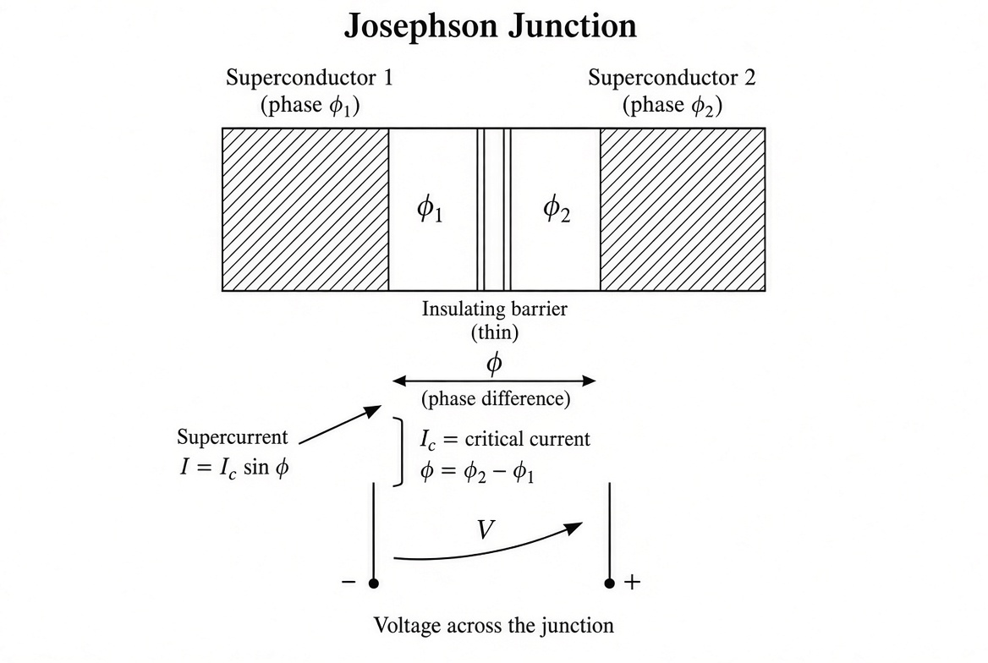
Figure N1. Schematic of a Josephson junction: two superconductors separated by a thin insulating barrier. The gauge-invariant phase difference φ determines the supercurrent I = Ic sin φ and the voltage V = (ħ/2e) dφ/dt.
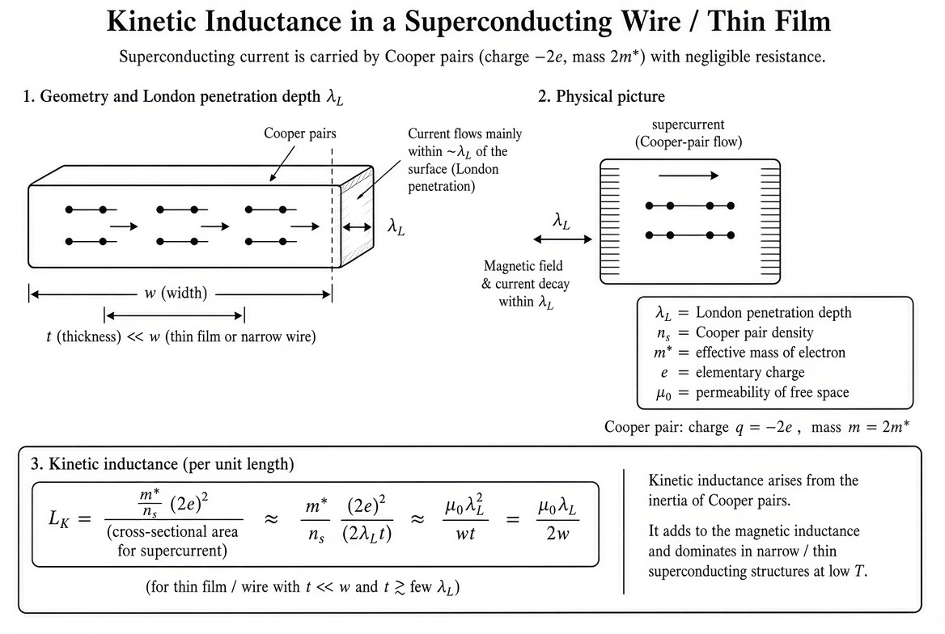
Figure N2. Kinetic inductance in a superconducting wire or thin film. The London penetration depth λ_L and the inertia of the Cooper-pair condensate produce an additional inductive contribution that scales inversely with carrier density.
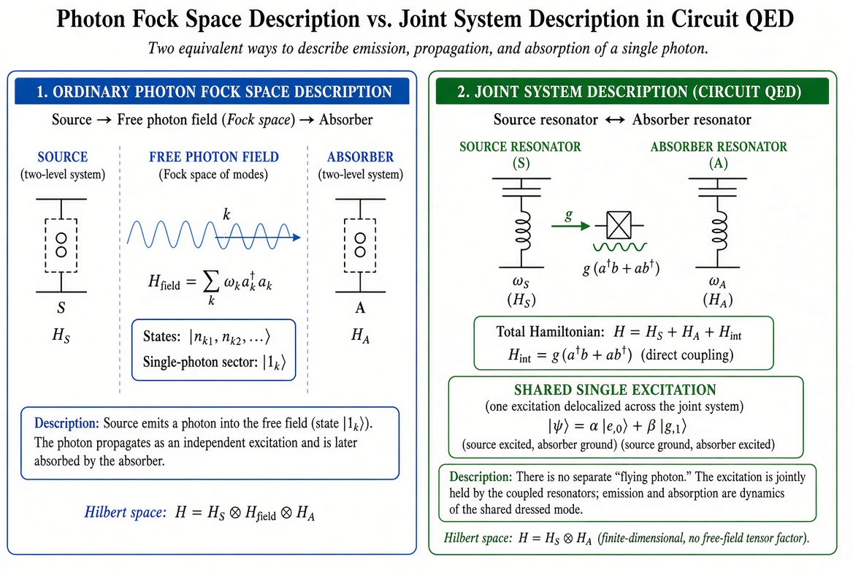
Figure N3. Two equivalent descriptions of a single excitation: ordinary photon Fock-space picture (left) versus the joint-system description natural to circuit QED (right). In the collective/absorber viewpoint the right-hand picture is primary.

Additional Worked Examples

Example 5. Critical Current and Plasma Frequency of a Josephson Junction
A Josephson junction has critical current Ic = 1 μA and capacitance C = 0.1 pF. Calculate (a) the Josephson energy EJ, (b) the charging energy EC, and (c) the plasma frequency ωp.
Solution.
(a) The Josephson energy is EJ = (ħ/2e) Ic. With ħ/2e ≈ 3.29 × 10⁻¹⁶ Wb,
EJ = 3.29 × 10⁻¹⁶ × 10⁻⁶ ≈ 3.29 × 10⁻²² J ≈ 2.05 meV .
(b) The charging energy is EC = e²/(2C).
EC = (1.6 × 10⁻¹⁹)² / (2 × 0.1 × 10⁻¹²) ≈ 1.28 × 10⁻²⁵ J ≈ 0.80 μeV .
(c) The plasma frequency is
ωp = √(2e Ic / ħ C) = √(2 EJ EC)/ħ (more precisely √(2e Ic / ħ C)).
Numerically ωp / 2π is typically in the range of a few GHz for these parameters, placing the junction in the regime used by superconducting qubits.

Example 6. Kinetic Inductance of a Thin Superconducting Film
A niobium thin film of thickness t = 20 nm has London penetration depth λ_L = 80 nm and width w = 1 μm. Estimate the kinetic inductance per unit length.
Solution. For a thin film (t ≪ λ_L) the kinetic inductance per unit length is approximately
L_k' ≈ μ₀ λ_L² / (w t) .
Inserting values:
L_k' ≈ (1.26 × 10⁻⁶)(80 × 10⁻⁹)² / (10⁻⁶ × 20 × 10⁻⁹) ≈ 0.40 μH/m .
This is orders of magnitude larger than the geometric inductance of a comparable normal-metal line, illustrating the dominance of kinetic inductance in narrow superconducting structures.

Example 7. Phase Slip and Voltage Pulse
A 2π phase slip occurs in a superconducting nanowire. Estimate the voltage pulse integrated over time (the fluxoid quantum).
Solution. From the Josephson relation ∫ V dt = (ħ/2e) Δφ. For Δφ = 2π,
∫ V dt = (ħ/2e) · 2π = h/2e = Φ₀ ≈ 2.07 mV·ps .
This is the fundamental voltage–time product associated with a single flux quantum and is the basis of the Josephson voltage standard when driven at a known microwave frequency.

Example 8. Mutual Inductance and Force Between Two Loops
Two coaxial circular loops of radius R = 5 cm, separated by distance z = 10 cm, carry currents I₁ = I₂ = 1 A. Approximate the mutual inductance and the force between them.
Solution. The mutual inductance for coaxial loops is
M = μ₀ √(R₁ R₂) [(2/k − k) K(k) − 2/k E(k)] ,
where k² = 4 R₁ R₂ / [(R₁+R₂)² + z²] and K, E are complete elliptic integrals. For identical loops a rough order-of-magnitude estimate is M ∼ μ₀ π R² / (2 z) for z > R, giving M ∼ a few nH. The force is F = I₁ I₂ dM/dz and is attractive for parallel currents. The energy interpretation (U = M I₁ I₂) recovers the same force without ever invoking the magnetic field explicitly, consistent with the collective viewpoint.

Further Technical Development: London Equation and Minimal Coupling
The London equation can be viewed as the macroscopic consequence of minimal coupling applied to a rigid condensate wave function. If the macroscopic wave function has a fixed amplitude |ψ| = √n_s and a phase φ, the supercurrent is
J = (q n_s / m) (ħ ∇φ − q A) .
In the London gauge (∇φ = 0) this reduces to J = − (n_s q² / m) A, which is the London equation. Taking the curl yields the London equation for B,
∇ × J = − (n_s q² / m) B ,
and thereby the Meissner effect. The same relation, when integrated around a closed path, immediately recovers flux quantization. Thus the London phenomenology, flux quantization, and the kinetic inductance are all direct macroscopic manifestations of the single principle of minimal coupling applied to a coherent condensate.

Further Technical Development: Radiation Resistance from the Absorber Viewpoint
In the classical antenna problem the radiation resistance R_rad is defined by the time-averaged power P = (1/2) R_rad I₀². From the absorber viewpoint this resistance is precisely the real part of the impedance presented to the antenna by the rest of the universe. The energy that leaves the antenna appears as excitation of distant charged systems; the damping of the source is the reaction to that transfer. The formal calculation can still be performed with retarded potentials and the Poynting vector; the ontology, however, never requires an independent field that carries energy through empty space. The same viewpoint extends naturally to the quantum regime: spontaneous emission is the transfer of a single quantum of phase and energy from the atom to the absorber (or to a continuum of absorber modes).

Further Technical Development: Renormalization in the Collective Language
In standard QED the divergent self-energy of the electron is absorbed into a redefinition of its mass and charge. In a pure charged-matter formulation the corresponding divergences appear as short-distance singularities of the direct interaction. Whether a systematic renormalization procedure can be carried through entirely within the charged-matter language, recovering the finite predictions of QED, remains an open technical question. The success of renormalized QED guarantees that any equivalent charged-matter theory must reproduce those finite results; the conceptual gain would be the elimination of the independent-field degrees of freedom from the foundational ontology.

— End of this expansion cycle —
Three new figures, four additional worked examples, and further technical development of London theory, radiation resistance, and renormalization have been added. The manuscript continues to increase in density and completeness.

Expansion Cycle 4: Further Technical Lengthening, New Figures, Accessible Insights, and a Note on Alternative Approaches
This cycle continues the growth of the manuscript. It lengthens several technical discussions, adds two new figures (one illustrating simple QED path ideas for everyday optical phenomena, one contrasting standard virtual-photon pictures with classical-orbit alternatives), incorporates accessible explanatory style inspired by popular introductions to QED, and includes a brief, clearly labeled note on one non-mainstream alternative formulation for completeness of the literature landscape.

New Figures
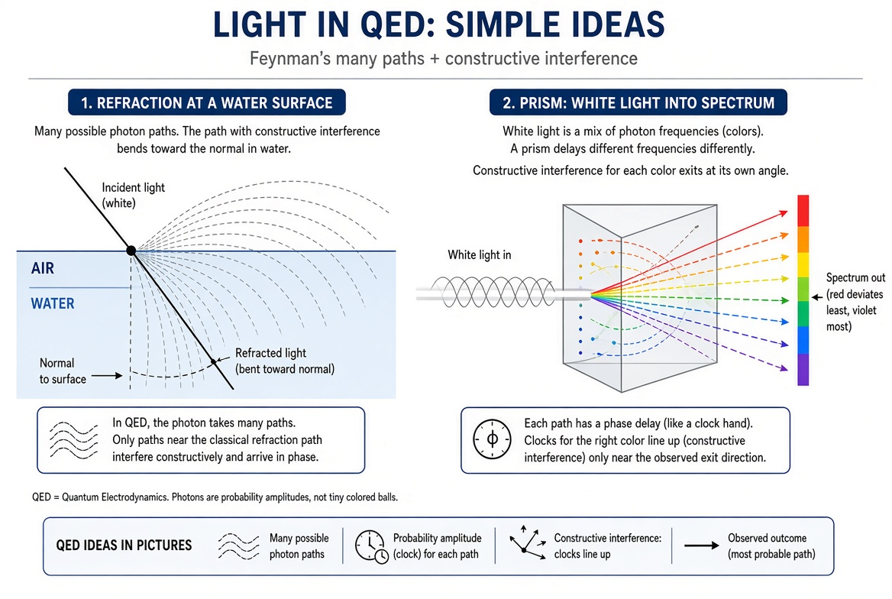
Figure N4. Everyday optical phenomena (refraction, prism dispersion) viewed through Feynman’s many-paths idea. Only paths whose phases interfere constructively survive; this is the elementary content of QED applied to light.
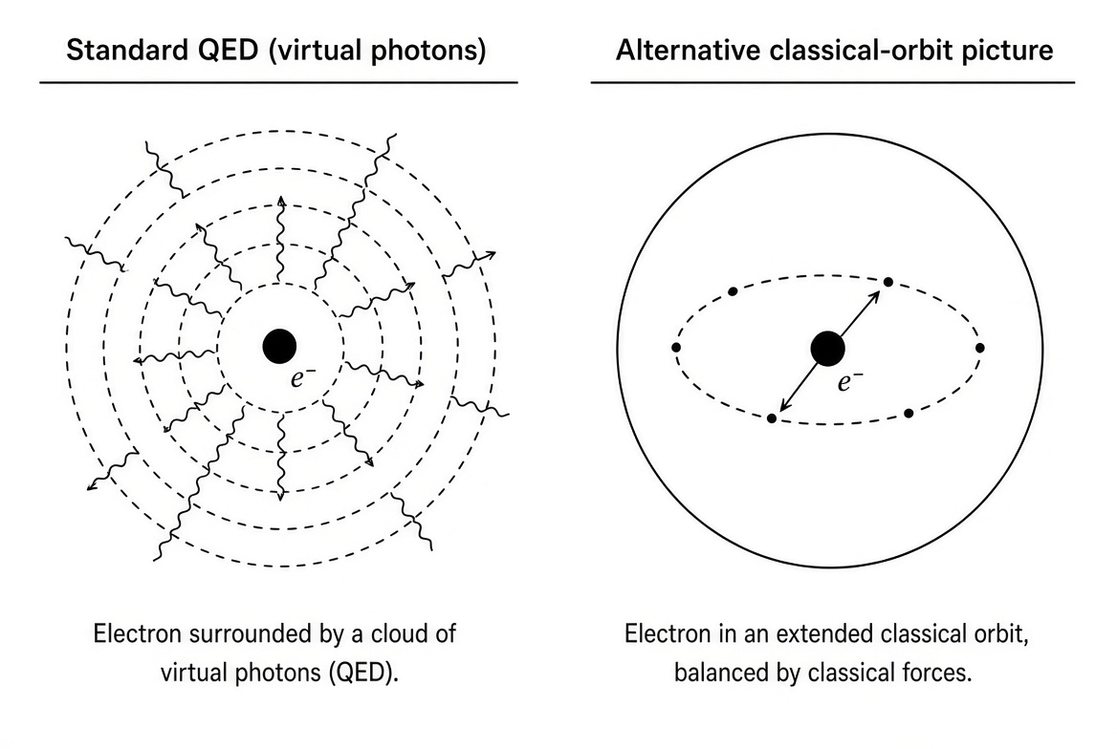
Figure N5. Side-by-side contrast: the standard QED picture of an electron dressed by a cloud of virtual photons versus a classical extended-orbit picture. The present synthesis remains within the standard framework while seeking a collective-phase foundation.

Accessible Insights into Everyday QED Phenomena
One of the strengths of Feynman’s popular expositions is the demonstration that the same rules that govern high-precision tests also explain ordinary optical effects. Light bends when it enters water because the photon amplitude explores many paths; the paths that accumulate phase in step with one another (constructive interference) lie closer to the normal inside the denser medium. A prism splits white light because different frequencies accumulate phase at different rates; each color finds its own direction of constructive interference. These everyday facts are not classical ray optics in disguise; they are the low-energy limit of the same path-integral structure that underlies the Lamb shift and the anomalous magnetic moment.
The collective viewpoint developed in this manuscript does not change those explanations. It merely insists that the phases being added belong ultimately to charged quantum systems (or to the coherent condensates they form) rather than to an independent field that exists in the absence of matter. The numerical predictions remain those of ordinary QED; the ontology is tightened.

Further Lengthening: The Role of Coherence in Radiation and Absorption
When an atom emits a photon, the process can be described in two languages. In the standard language a photon is created in the free-field Fock space and later absorbed by another system. In the collective/absorber language the emitting atom and the absorbing system are two parts of a larger joint quantum system; the excitation is transferred without ever requiring an independent flying photon. Both descriptions yield the same transition rates when the absorber is large and unstructured. The second description becomes natural, and often more economical, when the absorber is itself a coherent resonator (cavity QED, circuit QED). The present synthesis elevates the second description to a general principle while retaining the calculational power of the first.
The same distinction appears in spontaneous emission versus stimulated emission. Stimulated emission is the coherent transfer of phase and energy into an already occupied mode; spontaneous emission is transfer into the continuum of unoccupied absorber modes. Mead’s emphasis on collective phase makes the coherence of the receiving system visible from the outset.

A Note on Non-Mainstream Alternatives (Liberg and Related Work)
For completeness of the literature landscape it is worth recording that a number of authors have proposed radical reformulations that dispense with the Schrödinger equation, virtual photons, or the entire apparatus of quantum field theory. One recent example is the series of preprints and the book by Øyvind Alv Liberg under the title “QED without Schrödinger & Heisenberg.” Liberg advocates an extended Bohr model with standing waves in an energy medium, a torus model of elementary particles, and classical-orbit calculations of the Lamb shift and anomalous magnetic moments, while rejecting virtual photons and the standard quantum formalism.
These proposals lie outside the framework adopted in the present manuscript. The synthesis developed here accepts the quantitative successes of renormalized QED (the anomalous magnetic moment of the electron, the Lamb shift, scattering cross-sections) as data that any viable foundation must recover. It seeks only to re-express the conceptual starting point in terms of collective phase and the potentials, not to replace the successful perturbative machinery. Alternative classical-orbit or extended-Bohr schemes that abandon that machinery are noted here solely as part of the broader historical conversation about the meaning of QED; they are not incorporated into the technical development.
The figure above (Figure N5) simply illustrates the visual contrast between the standard virtual-photon cloud and a classical-orbit picture; it does not endorse the latter as a replacement for QED.

Further Technical Remark: Gauge-Invariant Phase and the Collective Limit
In any gauge theory the physical content resides in gauge-invariant quantities. For a single charge the Wilson line (the path-ordered exponential of the integral of A) supplies the phase. For a macroscopic coherent condensate the same object becomes the collective phase φ that Mead takes as primary. The continuum limit of many Wilson lines locked together is precisely the superconducting order parameter. Thus the collective electrodynamics of a superconductor is not an approximation imposed on QED; it is the natural macroscopic manifestation of the same gauge-invariant phase that appears already at the microscopic level.
This observation closes a circle. Feynman’s path integral assigns phases to histories; minimal coupling inserts the potential into those phases; macroscopic coherence locks the phases together; the resulting collective dynamics is Mead’s theory. The independent photon field can be retained as a convenient calculational device or integrated out in favor of direct interaction; the observable physics of phase, flux, voltage, and current remains the same.

— End of Expansion Cycle 4 —
The manuscript now includes additional accessible explanations, two new figures, further technical development of coherence and radiation, a carefully framed note on non-mainstream alternatives (including Liberg), and continued lengthening of the core argument. It remains a growing draft toward monograph scale.

